**76. Spring Boot - Spring Data JPA**

**Spring Data JPA Application Architecture**:

In our "Spring Data JPA" project we have no DAO layer. Instead we use "JpaRepository" here.

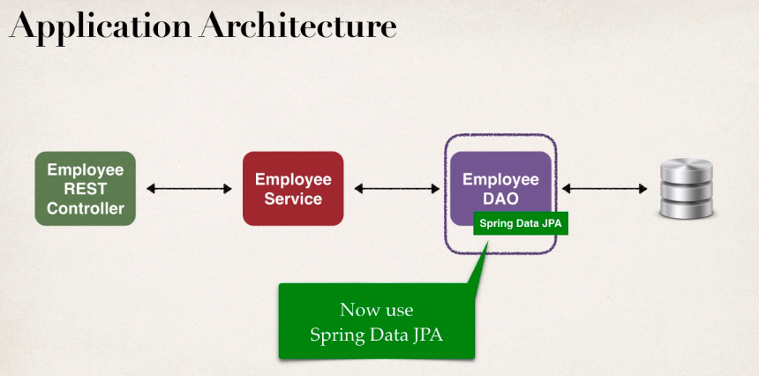

**The problem with DAO**:

1. For DAO we have to create a interface and an implementation Java class.
2. We need to create a separate interface and Java class for individual entity like, Employee, Customer, Student, Product, Book etc.
3. We have to repeat the same code again and again.

**Creating DAO**:

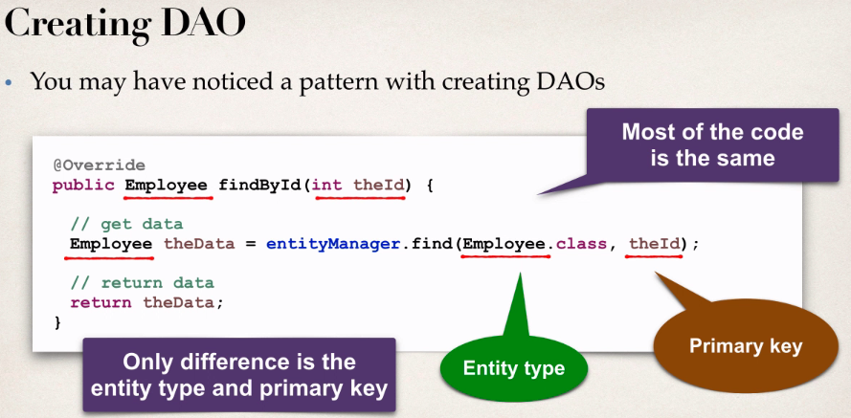

We notice that there is a pattern to creating the DAO. For example the above "findById()" method. Here most of the cade is same and the only deference is the Entity type and the primary key.

For creating entity's, we have to copy and past boiler-plate code again and again. We can solve this problem by using "Spring Data JPA"

**Spring Data JPA solution**:

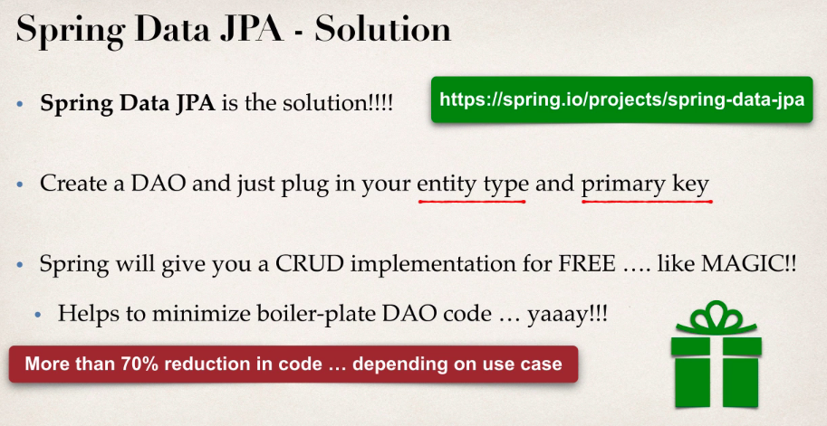

**Spring JpaRepository**:

1. Spring Data JPA provides the interface: JpaRepository
2. Exposes methods (some by inheritance from parents)
   1. findAll()
   2. findById()
   3. save()
   4. deleteById()

**Development Process**:

1. Extends JpaRepository interface
2. Use the repository in our app

**Step-1: Extends JpaRepository interface**:

**package** com.ruhul.springboot.cruddemo.dao;

**import** org.springframework.data.jpa.repository.JpaRepository;

**import** com.ruhul.springboot.cruddemo.entity.Employee;

**public** **interface** EmployeeRepository **extends** JpaRepository<Employee, Integer> {

}

For more info visit: <https://docs.spring.io/spring-data/jpa/docs/current/api/org/springframework/data/jpa/repository/JpaRepository.html>

**Step-2: Use Repository in App**:

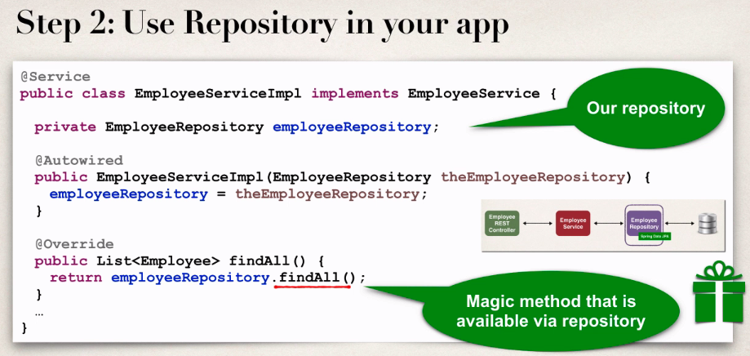

**Minimize the boilerplate code**:

By using Spring JpaRepository we can minimize the boilerplate code.

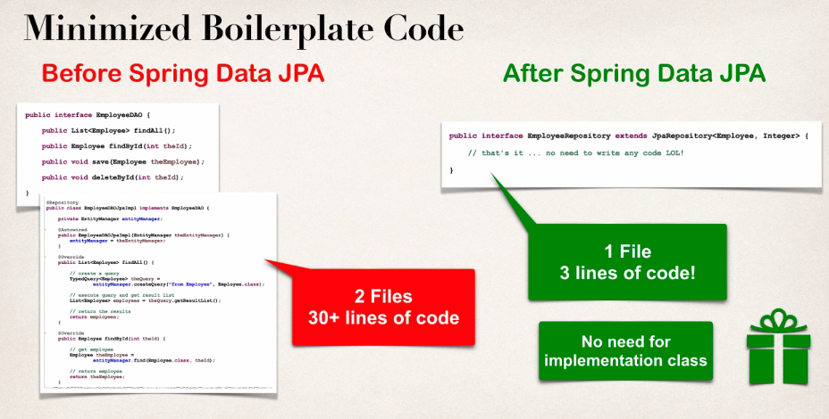

**Advanced Features**:

1. Extending and adding custom queries with JPQL
2. Query Domain Specific Language (Query DSL)
3. Defining custom methods (low-level coding)
4. For more info: <https://docs.spring.io/spring-data/jpa/docs/current/reference/html/#repositories.query-methods.details>

76. Spring Boot - Spring Data JPA